EWMA correlation: AUDUSD and USDJPY
Method 06 / daily log returns / lambda = 0.94 / Alpari D1 full available history

Study setup
Logical pair: AUDUSD , USDJPY
Broker symbols: AUDUSD_i , USDJPY_i
Snapshot: 2026-11-03_majors_alpari_D1
Timeframe: D1
Matched return window: 1999-01-05 to 2026-11-02 (UTC bar dates)
Matched return count n: 7199
Dropped unfinished last bar dated 2026-11-03 UTC after a tick-volume check against the prior complete day.
Lambda: 0.94 (today weight 0.06)
Burn-in ignored in path summaries and chart: first 60 updates
Mean adjustment: each leg demeaned by its mean on the matched rows
Seeds: c_0 = v_x,0 = v_y,0 = 0
Complete matched rows (Excel): AUDUSD-USDJPY_EWMA_D1.xlsx
Complete matched rows (HTML table): AUDUSD-USDJPY_EWMA_D1_data.html

Method carried forward
EWMA correlation updates covariance and variances of mean-adjusted daily log returns of close, ln(close_t / close_t-1), with lambda = 0.94 (6% weight on today's product or square, 94% on yesterday's EWMA state). Quotes are not inverted. Each leg is demeaned by its mean on the matched rows; that mean uses the full sample, so the rho path is a full-sample description, not a live filter. Seeds start at zero. Path summaries and the chart ignore the first 60 updates so the zero seed has faded. The headline is rho on the last day. rho is symmetric under swap of the two symbols. A high |rho| does not prove cause, lead-lag, or a trading signal. Today's return sits inside today's rho, so the estimate can only inform a later decision. Same-sample Pearson r is a side check only.

Results
Latest EWMA rho: -0.278350
Post-burn-in path (n=7139): mean=-0.232534, median=-0.281885, min=-0.851624, max=0.830877, std=0.337956
Share of post-burn-in days with |rho| >= 0.4: 40.34%; |rho| >= 0.7: 5.43%
Same-sample Pearson r: -0.088151
Latest rho minus r: -0.190200

Conclusion
Over 7199 matched daily log-return rows for AUDUSD and USDJPY (broker quote directions unchanged), latest EWMA rho with lambda=0.94 is -0.2784 (negative, weak recent linear link in this sample). After a 60-day burn-in, path mean is -0.2325, std is 0.3380, and the range is [-0.8516, 0.8309]. Same-sample Pearson r is -0.0882 (latest rho minus r = -0.1902). This does not establish cause, lead-lag, or a lasting trading rule.

Charts
Daily closes

Daily log returns
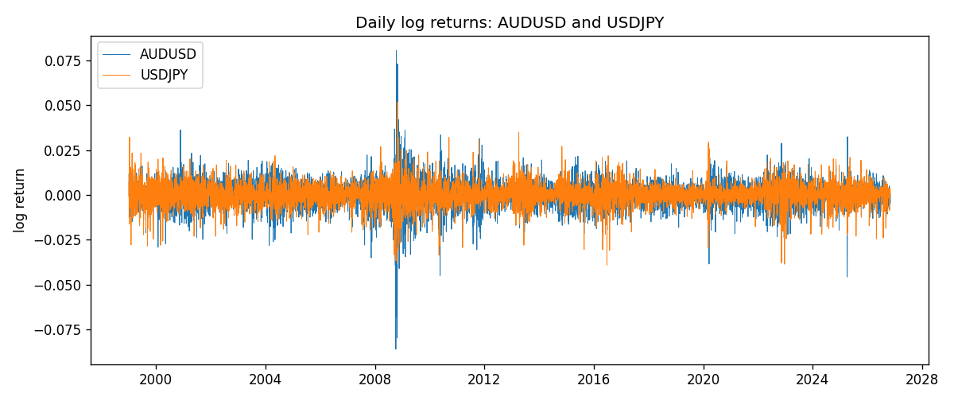
EWMA rho path with Pearson r reference
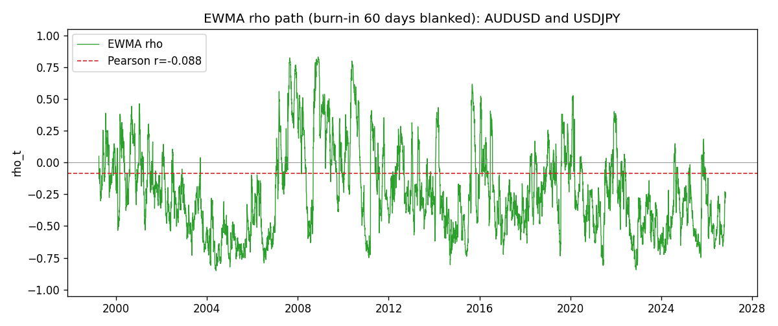

Data report
Every matched row that entered the EWMA recursion is stored in the sibling Excel workbook named AUDUSD-USDJPY_EWMA_D1.xlsx. That file is the complete data archive for redrawing charts. Embedding all rows as a Word table is impractical at this length; the Word file holds the column list, column summaries, and the first and last 15 matched rows.
Columns: time, AUDUSD_open, USDJPY_open, AUDUSD_high, USDJPY_high, AUDUSD_low, USDJPY_low, AUDUSD_close, USDJPY_close, AUDUSD_tick_volume, USDJPY_tick_volume, AUDUSD_spread, USDJPY_spread, AUDUSD_real_volume, USDJPY_real_volume, AUDUSD_log_return, USDJPY_log_return, AUDUSD_x_demeaned, USDJPY_y_demeaned, c_t, v_x, v_y, rho_t
Column summaries (matched calculation rows)
column | count | mean | std | min | 25% | 50% | 75% | max
AUDUSD_open | 7199 | 0.75196998 | 0.13527571 | 0.4785 | 0.661035 | 0.73142 | 0.809135 | 1.10284
USDJPY_open | 7199 | 113.81114 | 19.206896 | 75.693 | 104.4285 | 110.984 | 120.6925 | 163.824
AUDUSD_high | 7199 | 0.75602148 | 0.13583632 | 0.4878 | 0.6647 | 0.7349 | 0.815325 | 1.10795
USDJPY_high | 7199 | 114.30872 | 19.268446 | 76.001 | 104.881 | 111.442 | 121.26 | 163.978
AUDUSD_low | 7199 | 0.7479145 | 0.13459018 | 0.4775 | 0.6577 | 0.72758 | 0.80425 | 1.0975
USDJPY_low | 7199 | 113.28779 | 19.134887 | 75.402 | 103.89 | 110.53 | 120.17 | 163.628
AUDUSD_close | 7199 | 0.75202255 | 0.13525884 | 0.4786 | 0.661195 | 0.73175 | 0.809235 | 1.10169
USDJPY_close | 7199 | 113.824 | 19.222288 | 75.811 | 104.42 | 111.025 | 120.687 | 163.851
AUDUSD_tick_volume | 7199 | 77366.826 | 138149.99 | 109 | 5440 | 43349 | 71344.5 | 1234623
USDJPY_tick_volume | 7199 | 106151.62 | 179316.41 | 197 | 9927 | 53098 | 92761 | 1803508
AUDUSD_spread | 7199 | 30.814558 | 16.886804 | 0 | 13 | 30 | 50 | 50
USDJPY_spread | 7199 | 20.321434 | 17.631726 | 0 | 6 | 11 | 30 | 50
AUDUSD_real_volume | 7199 | 5.2435469e+09 | 1.2539788e+11 | 0 | 0 | 0 | 0 | 3.811512e+12
USDJPY_real_volume | 7199 | 3.470603e+10 | 1.6078743e+11 | 0 | 0 | 0 | 0 | 3.8834203e+12
AUDUSD_log_return | 7199 | 2.78e-05 | 0.00754502 | -0.08602525 | -0.00385397 | 0.00028846 | 0.00415332 | 0.0806166
USDJPY_log_return | 7199 | 4.761e-05 | 0.00620532 | -0.03908203 | -0.00320306 | 0.00011368 | 0.00340781 | 0.05184024
AUDUSD_x_demeaned | 7199 | -0 | 0.00754502 | -0.08605305 | -0.00388177 | 0.00026066 | 0.00412552 | 0.0805888
USDJPY_y_demeaned | 7199 | 0 | 0.00620532 | -0.03912965 | -0.00325067 | 6.607e-05 | 0.00336019 | 0.05179262
c_t | 7199 | -4.12e-06 | 3.996e-05 | -0.00012053 | -1.581e-05 | -7.79e-06 | -9e-07 | 0.00068668
v_x | 7199 | 5.689e-05 | 0.00010023 | 4e-08 | 2.617e-05 | 3.679e-05 | 5.89e-05 | 0.00173317
v_y | 7199 | 3.847e-05 | 3.189e-05 | 0 | 1.904e-05 | 3.089e-05 | 4.767e-05 | 0.00041229
rho_t | 7199 | -0.23223184 | 0.33772988 | -0.85162379 | -0.49088767 | -0.28220539 | -0.03292831 | 1
First 15 matched rows (selected columns)
time | AUDUSD_close | USDJPY_close | AUDUSD_log_return | USDJPY_log_return | AUDUSD_x_demeaned | USDJPY_y_demeaned | c_t | v_x | v_y | rho_t
1999-01-05 | 0.6215 | 111.92 | -0.00080418179 | -0.00017868311 | -0.00083197918 | -0.00022629768 | 1.1296498e-08 | 4.1531362e-08 | 3.0726385e-09 | 1
1999-01-06 | 0.6289 | 112.77 | 0.011836351 | 0.0075660159 | 0.011808553 | 0.0075184013 | 5.3375052e-06 | 8.4055552e-06 | 3.3944698e-06 | 0.99923845
1999-01-07 | 0.6345 | 111.33 | 0.0088650256 | -0.012851583 | 0.0088372282 | -0.012899197 | -1.822334e-06 | 1.2587018e-05 | 1.3174159e-05 | -0.14151586
1999-01-08 | 0.6347 | 110.8 | 0.00031515916 | -0.0047719894 | 0.00028736176 | -0.004819604 | -1.7960921e-06 | 1.1836752e-05 | 1.3777424e-05 | -0.14064631
1999-01-11 | 0.6393 | 109.02 | 0.0072213815 | -0.016195423 | 0.0071935841 | -0.016243037 | -8.6990659e-06 | 1.4231406e-05 | 2.8780954e-05 | -0.42982941
1999-01-12 | 0.6362 | 112.6 | -0.0048608485 | 0.032310364 | -0.0048886459 | 0.032262749 | -1.7640391e-05 | 1.4811453e-05 | 8.9507197e-05 | -0.48448508
1999-01-13 | 0.6312 | 113.52 | -0.0078902098 | 0.0081373171 | -0.0079180072 | 0.0080897026 | -2.0425227e-05 | 1.7684456e-05 | 8.8063363e-05 | -0.51757515
1999-01-14 | 0.6295 | 113.52 | -0.002696916 | 0 | -0.0027247134 | -4.7614577e-05 | -1.9191929e-05 | 1.7068832e-05 | 8.2779697e-05 | -0.51056944
1999-01-15 | 0.634 | 114.15 | 0.007123101 | 0.0055343401 | 0.0070953036 | 0.0054867255 | -1.5704615e-05 | 1.9065302e-05 | 7.9619165e-05 | -0.40308499
1999-01-18 | 0.6346 | 114.16 | 0.00094592471 | 8.7600193e-05 | 0.00091812732 | 3.9985616e-05 | -1.4760135e-05 | 1.7971962e-05 | 7.4842111e-05 | -0.40245708
1999-01-19 | 0.6392 | 113.52 | 0.0072225153 | -0.0056219403 | 0.0071947179 | -0.0056695549 | -1.6321978e-05 | 1.9999482e-05 | 7.2280215e-05 | -0.42929289
1999-01-20 | 0.64 | 112.91 | 0.0012507819 | -0.0053879917 | 0.0012229845 | -0.0054356062 | -1.5741519e-05 | 1.8889254e-05 | 6.9716151e-05 | -0.433783
1999-01-21 | 0.6405 | 113.87 | 0.00078094498 | 0.0084664056 | 0.00075314759 | 0.0084187911 | -1.4416592e-05 | 1.7789933e-05 | 6.9785745e-05 | -0.40915899
1999-01-22 | 0.6327 | 114.56 | -0.012252745 | 0.0060412564 | -0.012280543 | 0.0059936418 | -1.7967907e-05 | 2.5771241e-05 | 6.7754025e-05 | -0.42999389
1999-01-25 | 0.6302 | 113.72 | -0.0039591468 | -0.0073594164 | -0.0039869442 | -0.007407031 | -1.5117948e-05 | 2.517871e-05 | 6.698063e-05 | -0.36813023
Last 15 matched rows (selected columns)
time | AUDUSD_close | USDJPY_close | AUDUSD_log_return | USDJPY_log_return | AUDUSD_x_demeaned | USDJPY_y_demeaned | c_t | v_x | v_y | rho_t
2026-10-13 | 0.69821 | 158.305 | 0.0035007712 | -0.0018932826 | 0.0034729738 | -0.0019408971 | -8.474518e-06 | 1.4138197e-05 | 1.9770317e-05 | -0.50688703
2026-10-14 | 0.69715 | 158.317 | -0.0015193215 | 7.5800166e-05 | -0.0015471189 | 2.8185589e-05 | -7.9686633e-06 | 1.3433519e-05 | 1.8584146e-05 | -0.50433519
2026-10-15 | 0.69191 | 158.024 | -0.0075447063 | -0.0018524319 | -0.0075725037 | -0.0019000465 | -6.627257e-06 | 1.6068077e-05 | 1.7685708e-05 | -0.39313403
2026-10-16 | 0.69426 | 157.964 | 0.0033906408 | -0.00037976126 | 0.0033628434 | -0.00042737584 | -6.3158535e-06 | 1.5782515e-05 | 1.6635524e-05 | -0.38978551
2026-10-19 | 0.6978 | 158.517 | 0.0050859986 | 0.0034946841 | 0.0050582012 | 0.0034470695 | -4.890744e-06 | 1.6370688e-05 | 1.635033e-05 | -0.29893598
2026-10-20 | 0.70022 | 158.16 | 0.0034620426 | -0.0022546642 | 0.0034342452 | -0.0023022788 | -5.0716947e-06 | 1.609609e-05 | 1.5687339e-05 | -0.31916721
2026-10-21 | 0.70275 | 158.108 | 0.0036066384 | -0.00032883504 | 0.003578841 | -0.00037644962 | -4.8482282e-06 | 1.589881e-05 | 1.4754602e-05 | -0.31654612
2026-10-22 | 0.70186 | 156.755 | -0.0012672558 | -0.0085942669 | -0.0012950532 | -0.0086418815 | -3.8858328e-06 | 1.5045511e-05 | 1.8350253e-05 | -0.23386197
2026-10-23 | 0.70353 | 156.81 | 0.0023765656 | 0.00035080446 | 0.0023487682 | 0.00030318989 | -3.6099554e-06 | 1.4473784e-05 | 1.7254753e-05 | -0.22843173
2026-10-26 | 0.70128 | 157.458 | -0.0032032829 | 0.0041238746 | -0.0032310803 | 0.0040762601 | -4.1836015e-06 | 1.4231749e-05 | 1.7216422e-05 | -0.2672697
2026-10-27 | 0.70245 | 157.894 | 0.0016669876 | 0.0027651658 | 0.0016391902 | 0.0027175512 | -3.6653104e-06 | 1.3539061e-05 | 1.6626541e-05 | -0.24429553
2026-10-28 | 0.70533 | 157.743 | 0.0040915541 | -0.00095679538 | 0.0040637567 | -0.00100441 | -3.6902925e-06 | 1.3717564e-05 | 1.5689479e-05 | -0.25154635
2026-10-29 | 0.70245 | 157.683 | -0.0040915541 | -0.00038043789 | -0.0041193515 | -0.00042805247 | -3.363077e-06 | 1.3912654e-05 | 1.4759104e-05 | -0.23469391
2026-10-30 | 0.70316 | 157.516 | 0.0010102376 | -0.0010596481 | 0.00098244024 | -0.0011072627 | -3.2265615e-06 | 1.3135806e-05 | 1.394712e-05 | -0.23837973
2026-11-02 | 0.69971 | 157.933 | -0.0049184984 | 0.0026438521 | -0.0049462958 | 0.0025962375 | -3.8034734e-06 | 1.3815608e-05 | 1.351472e-05 | -0.2783504

